

Does your older home need repairs?

Are you a developer and want to create affordable Housing?

Do you own rental units
that need upgrading?

Are you a first-time homeowner
and need assistance with the
Down Payment?

We can help!


Our Mission:
The mission of the EIRHC Housing Trust Fund is to assist in the provision of providing decent, safe and affordable housing, as well as providing access to the resources for creating housing opportunities to the families served in eastern Iowa. The emphasis is to provide economic assistance to benefit the -moderate, very low, and extremely low-income residents of Dubuque, Delaware, Jackson, Cedar and Clinton Counties for a variety of housing needs.
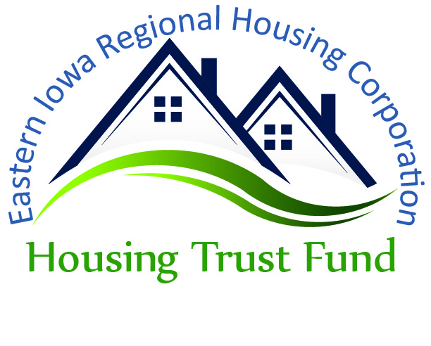

Eastern Iowa Regional Housing Corporation
Local Housing Trust Fund

7600 Commerce Park
Dubuque, IA 52002

800-942-4648, Ext. 215
563-690-5732

Eastern Iowa Regional Housing Corporation
Housing
Trust Fund

Promoting decent, safe and affordable housing.
Who Can We Help?
The Eastern Iowa Regional Housing Corporation Local Housing Trust Fund will assist individuals, community organizations, non-profit and for-profit developers in development, rehabilitation and repair projects that improve the condition of both rental and owner occupied affordable housing in our area.

Projects and activities funded must s e r v e area households with incomes less than 80% of the statewide median family income (MFI). At least 30% of the distributions will be used to benefit extremely low income households (households with less than 30% of the statewide median family income).
 | Household Size
County | 1 | 2 | 3 | 4 | 5 | 6
Cedar  ELI – 30%  VLI – 50%  LI – 80% | 14,950  24,900  39,850 | 17,100  28,450  45,550 | 20,090  32,000  51,250 | 24,250  35,550  56,900 | 28,410  38,400  61,500 | 32,570  41,250  66,050
Clinton  ELI – 30%  VLI – 50%  LI – 80% | 14,250  23,750  38,000 | 16,300  27,150  43,400 | 20,090  30,550  48,850 | 24,250  33,900  54,250 | 28,410  36,650  58,600 | 35,570  39,350  62,950
Delaware  ELI – 30%  VLI – 50%  LI – 80% | 14,150  23,600  37,700 | 16,200  26,950  43,100 | 20,090  30,300  48,500 | 24,250  33,650  53,850 | 28,410  36,350  58,200 | 32,570  39,050  62,500
Dubuque  ELI – 30%  VLI – 50%  LI – 80% | 13,900  23,100  37,000 | 15,930  26,400  42,250 | 20,090  29,700  47,550 | 24,250  33,000  52,800 | 28,410  35,650  57,050 | 32,570  38,300  61,250
Jackson  ELI – 30%  VLI – 50%  LI – 80% | 13,000  21,650  34,650 | 15,930  24,750  39,600 | 20,090  27,850  44,550 | 24,250  30,900  49,450 | 28,410  33,400  53,450 | 32,570  35,850  57,400

What Will We Fund?


Eligible properties include both owner occupied and rental units in our five (5) county region
• Owner occupied re-
quirements: Applicant must occupy the prop- erty and maintain the improvements for the life of the loan. Property
must be in compliance with health and safety codes. Applicant must have title to the home at the time of application. Taxes and insurance must be current.
• Rental requirements: Units must be rented to households with incomes not more than 80% of the statewide MFI. All dwelling units must rent at or below the County Fair Market Rent, as determined by HUD throughout the life of the loan. Borrower must provide 25% in match funds for the amount of the program loan, with a $25,000 max per unit. Units must, at the completion of project, meet Section 8 Housing Quality Standards and be in compliance with all applicable local health and safety codes. Taxes and insurance must be current.

Eligible projects include rehabs and repairs of exist- ing housing, including, but not limited to: plumbing, electrical, roofing, struc- tural, energy efficiency, lead based paint issues and handicap accessibility.

How Do You Apply?


Applications can be obtained
by contacting Carl W. Reimer at
563-690-5732 or
800-942-4648 ext 215
or down-loaded at
www.eirha.org.

EIRHC HTF
Board Members:

Randy Schmerbach, Chair, Dubuque County
Dave Heiar, Vice Chair, Jackson County
Wayne Breckon, Treasurer, Dubuque County

Elise Bergan, Delaware County
Lynne Pinegar, Cedar County
Nathan Sondgeroth, Clinton County
Matt Trannel, Jackson County
Steve Lidner, Clinton County
Chris Nosbisch, Cedar County
Ray Stephans, Dubuque County
Brenda Tebbe, Jackson County
Tim Vick, Delaware County
Donna Boss, Delaware County

Eastern Iowa Regional Housing Corporation
Local Housing Trust Fund


This is an equal opportunity program; Discrimination is prohibited by Federal Law

